**Advanced payments in In-House Loans**

For In-House loan advanced payments, a customer can have an option to apply the advanced payments to the principal amount only or apply it to both the principal and computed interest.

**Cash Register**

**Application to both Principal and Computed Interest**

To apply advanced payment to both the principal and computed interest amount, the ‘Apply to Principal Only’ option should reflect ‘NO.’ This is the default option.

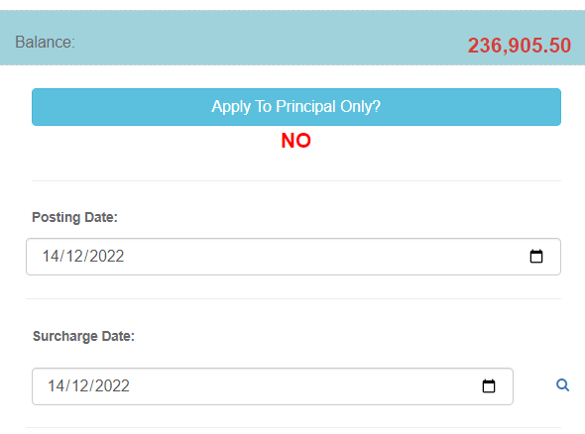

When ‘NO’ is selected, all computed interest amount of the selected line item will be included in the total amount to be paid even if the line item is not currently due.

On the screenshot below, only the line item dated December 14, 2022 is currently due. Due line items have a rent font on the date.

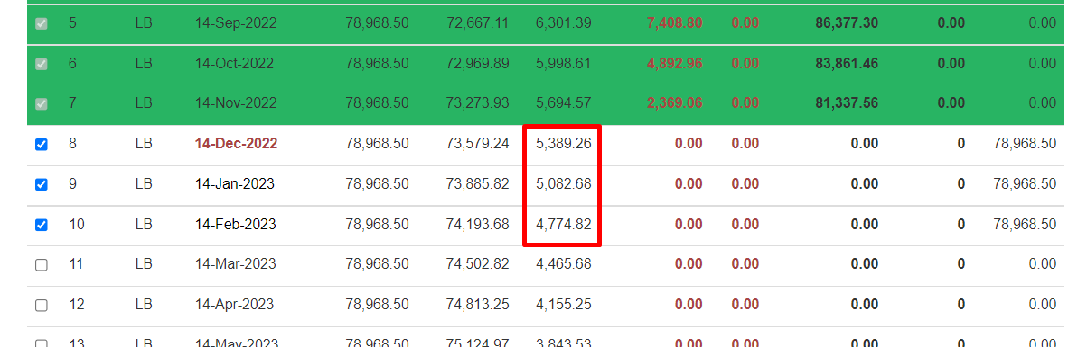

**Application to Principal only**

To apply advanced payment to the principal amount only, the ‘Apply to Principal Only’ option should reflect ‘YES.’ Click on the button to toggle.

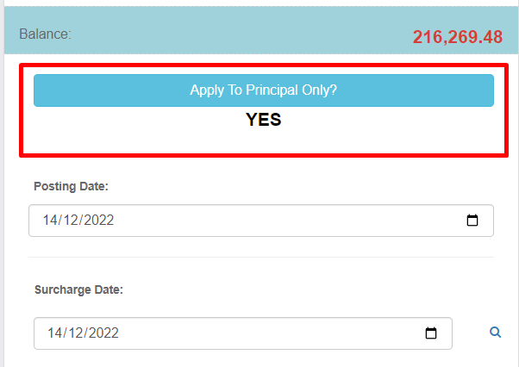

When ‘YES’ is selected, only computed interest amount of the line items due will be included in the total amount to be paid. Line items not due will reflect a zero interest amount.

On the screenshot below, only the line item dated December 14, 2022 is currently due, hence, all other line items reflected a zero interest amount. Due line items have a rent font on the date.

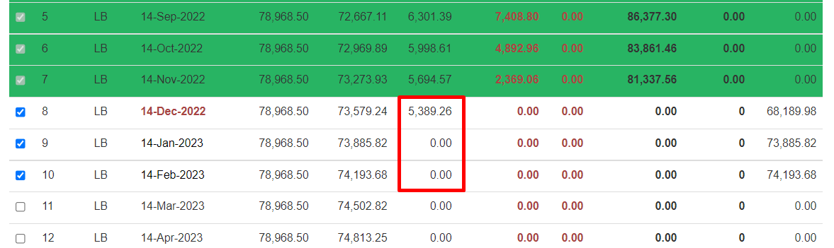

Add and review other details of the transaction, then proceed to the add the payment.

**Restructuring**

For advanced payments that are applied to principal only, changes to the amortization balance should be made as computed interest will now be based on the amortization balance.

In the restructuring module, select the account to be updated.

Once the account to be restructured is selected, options selected in the restructuring details should be the following:

1. Update Amortization balance - YES

* Since interest will be recomputed based on the latest TCP balance, select ‘YES’ on the ‘Update Amortization Balance’ field to trigger re-computation of interest.

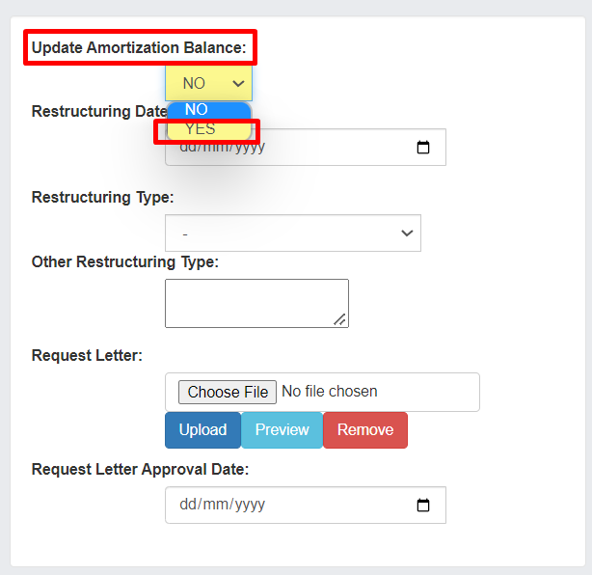

1. Retain Monthly Amortization – YES

* By default, selecting Yes on Update Amortization Balance triggers re-computation of monthly amortization. To retain the original monthly amortization, select ‘YES’.

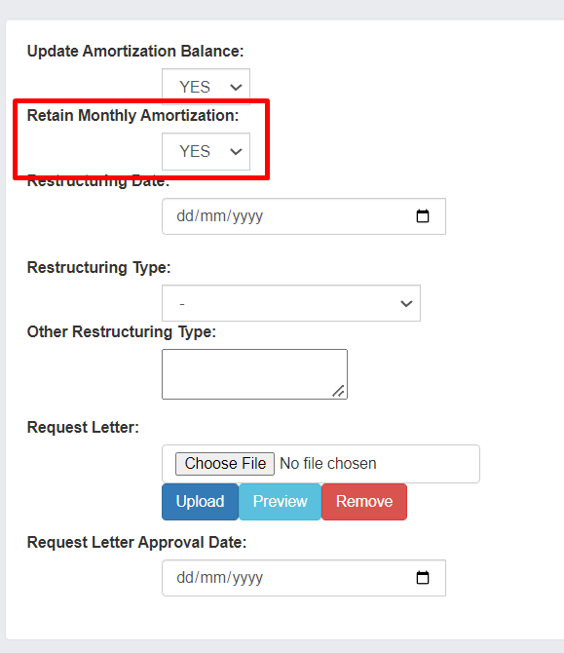

1. Restructuring Date – enter update date.
2. Restructuring Type – select Interest Recalculation
3. Request letter – upload source document of update.
4. Request letter Approval Date – enter date of source document.

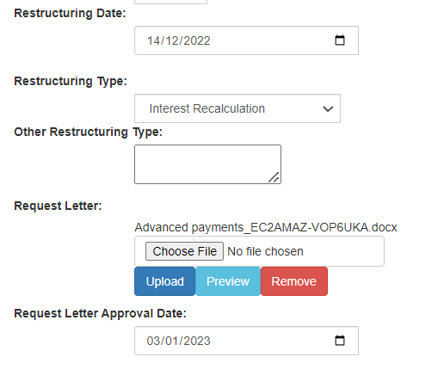

1. Document Date –

* To update the due dates of the amortization schedule, enter the current date or restructuring date as document date.

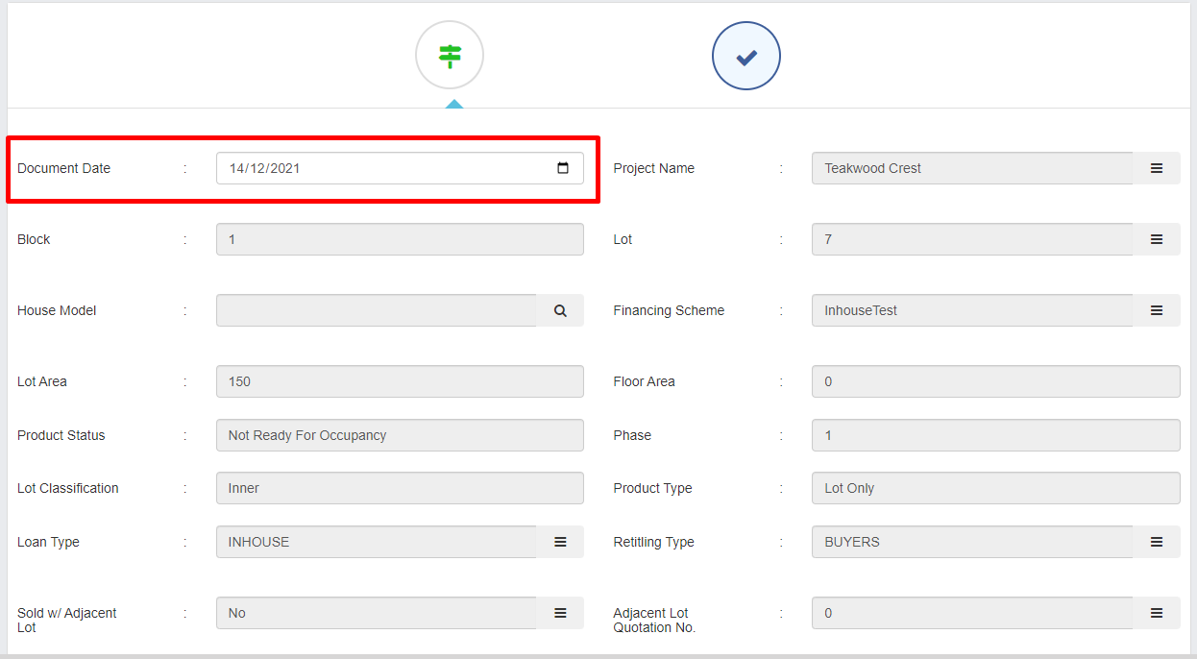

Should there be no other details to be updated, click ‘Next’.

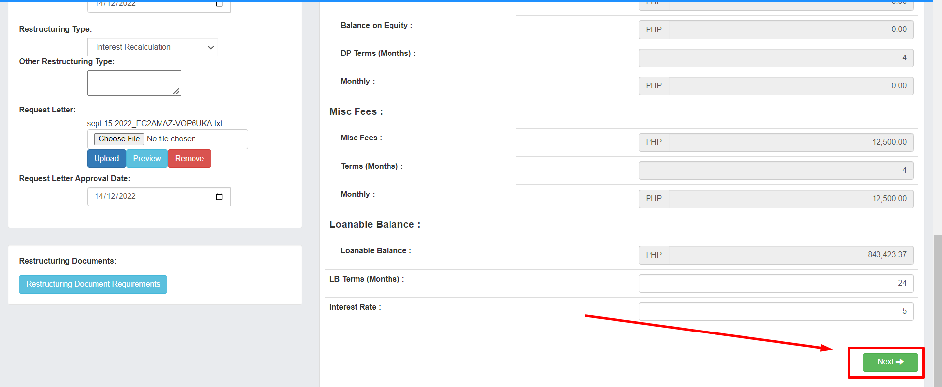

Updated Amortization Schedule

1. Miscellaneous and Principal – unpaid miscellaneous and principal payments will now be due on the month after the document date entered.

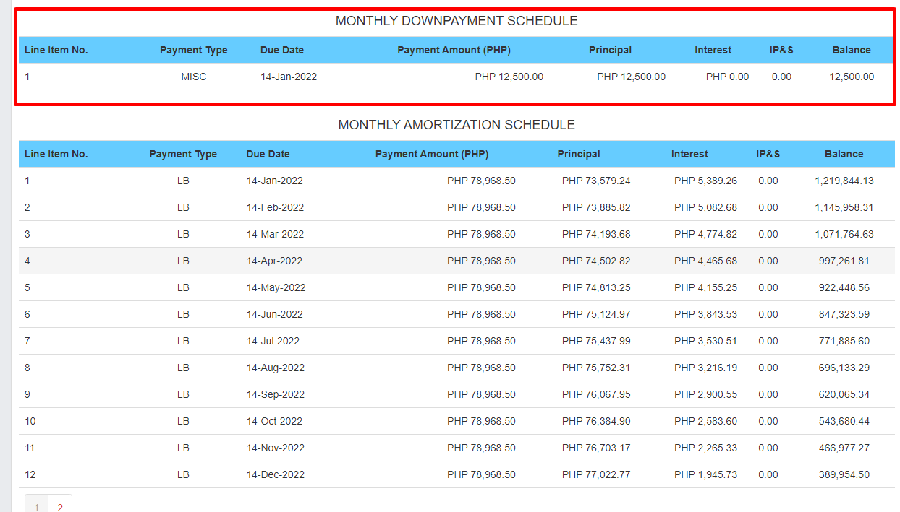

Click on the next page to check if all amortization line items are correct.

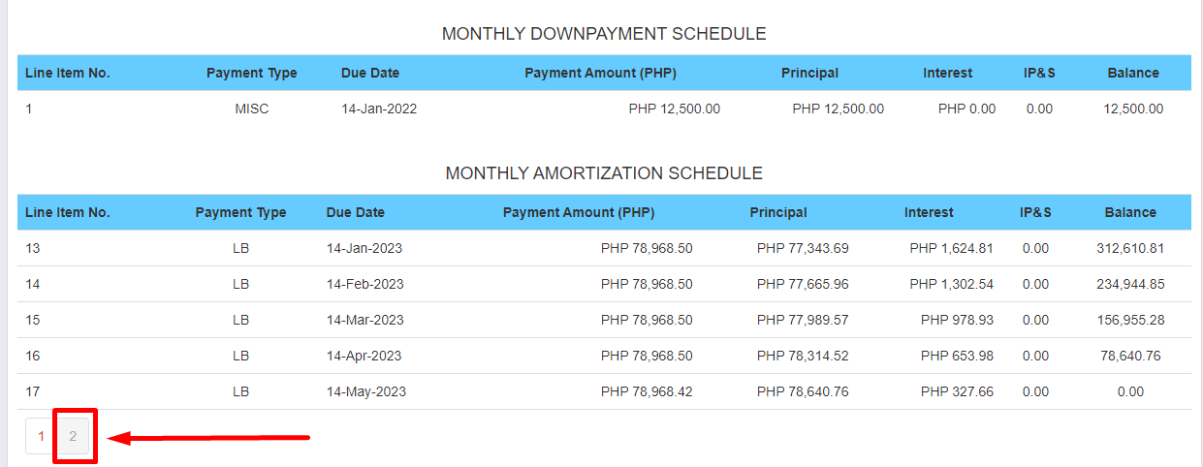

Once reviewed, click ‘Update’. Then, click ‘Yes.’

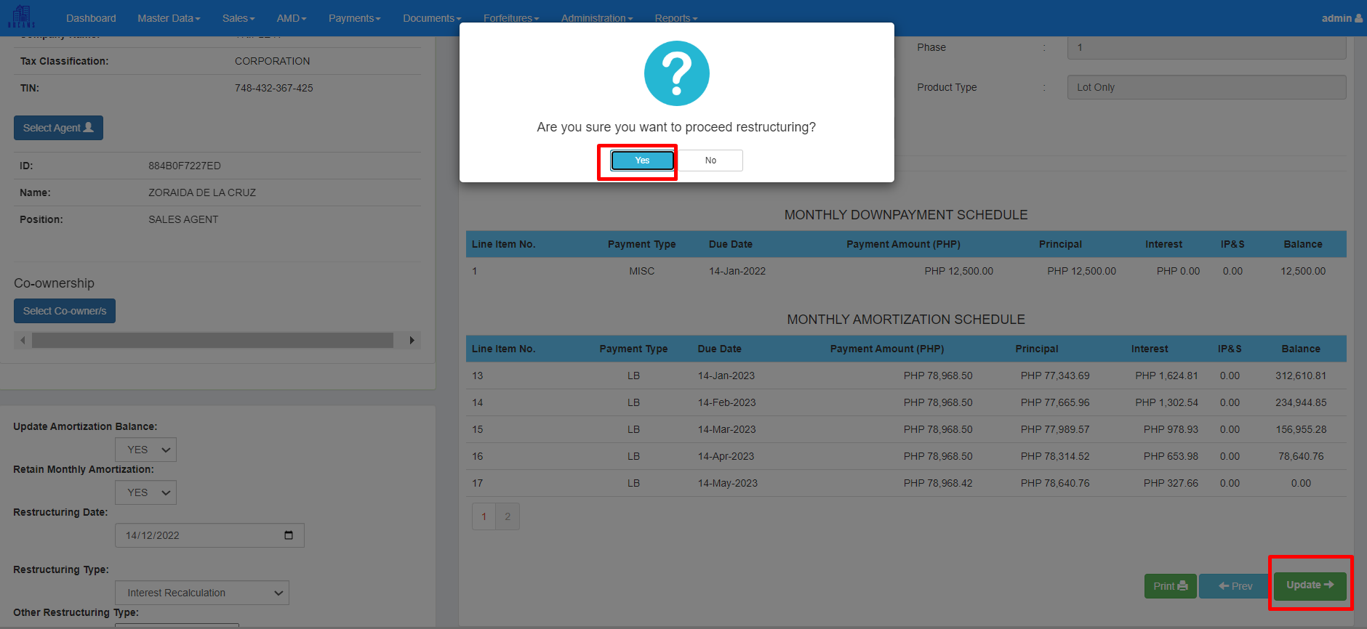

The updated amortization will now be reflected on the Cash Register Module.